Submit a Comment to FDA Supporting CRN’s NAC Citizen Petition
Last Updated: October 6, 2021
Instructions for companies, healthcare practitioners, and consumers:
- Use the relevant sections of CRN’s sample letter to submit a comment to the Food and Drug Administration (FDA) or create your own comment.
  - If creating your own comment, be sure to include your “ask” – that the federal Food and Drug Administration (FDA) expeditiously provide a substantive response to legal positions raised in a Council for Responsible Nutrition (CRN) Citizen Petition calling for resolution to an issue affecting consumer access to a legal and safe dietary supplement ingredient, N-acetyl-l-cysteine (NAC).
  - Click here for an editable Word file
- Sections marked as “FOR EVERYONE” can be used regardless of whether you are a company, healthcare practitioner, or consumer.
- If using CRN’s sample comment letter, fill-in text prompts.
- Submit your comment to FDA under the CRN NAC Citizen Petition Docket – Docket FDA-2021-P-0523
  - Instructions for submitting comments:
    - Navigate to this webpage: https://www.regulations.gov/document/FDA-2021-P-0523-0001
    - Click on the blue “Comment” button on the top, left-hand side of the webpage
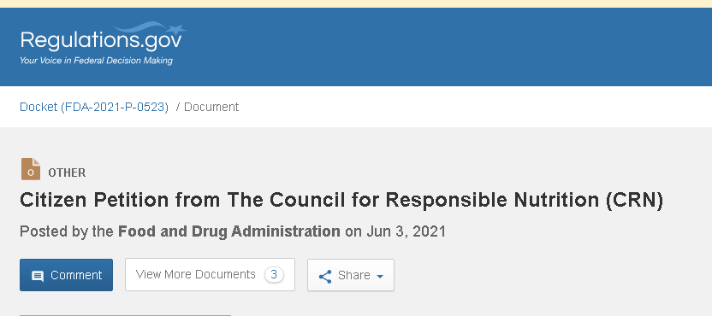
    - Follow the instructions on Regulations.gov – you can upload your comment as a word file, PDF, or other file type listed on Regulations.gov
- Send a copy of your comment to CRN: WDumais@crnusa.org.

FOR EVERYONE:

[Company Banner if applicable]
(Date)
Division of Dockets Management
U.S. Food and Drug Administration
Department of Health and Human Services
5630 Fishers Lane, Rm 1061
Rockville, Maryland 20852

Re: Docket FDA-2021-P-0523 – Response to CRN Citizen Petition Requesting FDA Allow N-Acetyl-L-Cysteine (NAC) to be Marketed as a Dietary Supplement
Dear Sir or Madam:
On behalf of (COMPANY/FIRM NAME/NAME), I/we ask the federal Food and Drug Administration (FDA) to expeditiously provide a substantive response to legal positions raised in a Council for Responsible Nutrition (CRN) Citizen Petition calling for resolution to an issue affecting consumer access to a safe dietary supplement ingredient, N-acetyl-l-cysteine (NAC). CRN and members of Congress have expressed significant concern over the legality of FDA’s position that the Food, Drug, and Cosmetic Act (FDCA) prohibits manufacturers from marketing products containing NAC as dietary supplements. CRN first raised this issue with the agency in December 2020, but has still not received a substantive response regarding FDA’s position.
V1 - FOR COMPANIES:
(Company Name) is the (manufacturer)/(supplier) of ________________ (brands or products). If a CRN member company add the following: Our company is a proud member of the Council for Responsible Nutrition (CRN), a membership-based trade association representing the mainstream and responsible dietary supplement and functional food industry. CRN’s membership includes suppliers of dietary supplement ingredients, as well as manufacturers and marketers of branded and private label products available to consumers through a variety of distribution channels: mass market, health food stores, mail order, and direct sales.
V2 - FOR DOCTORS/PRACTITIONERS:
I am a medical professional with over (XXX) years of experience and expertise within my field. (Enter any other information about accolades, certifications, etc. that speak to your credentials). As a part of my field and/or practice, I have recommended my patients take NAC dietary supplements for a variety of different purposes. Because of FDA’s actions, my patients have found it difficult to access these safe and beneficial products.
V3 - FOR CONSUMERS:
I am a consumer that has purchased NAC dietary supplement products to support my health and wellbeing. I actively use these products and was very frustrated to learn that retailers like Amazon and others, have removed these products and brands from their shelves and online stores due to FDA’s actions.
*** FOR EVERYONE
NAC has safely been on the market for over 25 years. However, in July 2020, FDA took unprecedented action to prohibit sales of NAC as a dietary supplement by enacting a sudden and drastic policy change in the manner in which the agency treats this ingredient. This was done by issuing multiple warning letters, asserting that products containing NAC cannot be marketed as dietary supplements under section 201(ff)(3)(B)(i) of the Food, Drug, and Cosmetic Act. FDA’s warning letters assert that NAC was approved as a new drug in 1963 and, to FDA’s knowledge, was not marketed as a dietary supplement prior to that date. As such, FDA claims that products containing NAC cannot be marketed as dietary supplements. FDA has failed to provide any rationale for this policy change other than the basic assertions made in these warning letters.
For decades, manufacturers have safely marketed products containing NAC as dietary supplements in the United States. There are currently hundreds of dietary supplements containing NAC on the market, and thousands of consumers have come to rely on these products. The safety of NAC has been widely recognized, including by authoritative government bodies, such as the National Institutes of Health.
FDA cites the Dietary Supplement Health and Education Act (DSHEA), which prohibits an ingredient from being used in a supplement if that ingredient was first approved as a drug. CRN cites to a number of legal concerns in its Citizen Petition that must be addressed by FDA. For example, the form of NAC first approved, as a drug is different from the form of NAC found in supplements. Further, CRN notes that FDA is applying DSHEA in a retroactive manner that Congress never intended and courts likely would not support. NAC as a supplement coexisted with NAC as a drug well before DSHEA was enacted. For over 25 years, since the passage of DSHEA, FDA has not objected to the continued use of NAC in dietary supplements. FDA has had amble opportunity to object. The only objection in 25 years that FDA can point to is an objection sent to one company for a form of NAC that appears to be different from the form that is the subject of FDA’s current enforcement actions. Subsequent to that objection, FDA affirmatively stated in another communication to another company that NAC was a legal dietary ingredient.
While FDA reviews the legality of its policy reversal, consumers and manufacturers are being harmed as access to these safe and beneficial supplements is reduced. Major retailers, such as Amazon, have removed NAC dietary supplements from their platforms – causing economic harm to manufacturers and harm to consumers that rely on these supplements for their wellbeing and health.
To prevent further harm, I/we urge FDA to review its position and revert to its longstanding policy of allowing NAC to be marketed as a dietary supplement. Thank you in advance for your consideration of this request and I look forward to FDA expeditiously responding to CRN’s Citizen Petition on this matter.
Sincerely,

(Enter Name/Company Executive Name Here)
cc: Council for Responsible Nutrition

Citizen Petition submitted by the Council for Responsible Nutrition to the U.S. Food and Drug Administration, June 1, 2021, available at: https://www.crnusa.org/sites/default/files/Daily/2021-06/CRN%20NAC%20Citizen%20Petition%20--%206.1.21%20Final.pdf.
The Council for Responsible Nutrition (CRN), founded in 1973 and based in Washington, D.C., is the leading trade association representing dietary supplement and functional food manufacturers, marketers and ingredient suppliers. CRN companies produce a large portion of the functional food ingredients and dietary supplements marketed in the United States and globally. Our member companies manufacture popular national brands as well as the store brands marketed by major supermarkets, drug stores and discount chains. These products also include those marketed through natural food stores and mainstream direct selling companies. CRN represents more than 180 companies that manufacture dietary ingredients, dietary supplements and/or functional foods, or supply services to those suppliers and manufacturers. Our member companies are expected to comply with a host of federal and state regulations governing dietary supplements and food in the areas of manufacturing, marketing, quality control and safety. Our supplier and manufacturer member companies also agree to adhere to additional voluntary guidelines as well as to CRN’s Code of Ethics. Learn more about us at www.crnusa.org.
Letter to Sevo Nutraceuticals, Inc. from FDA responding to April 27, 2016 petition (available at https://www.fda.gov/media/119441/download).

